

8 captures
5 Oct 2024 - 10 Dec 2025

Sep | DEC | Jan
 | 10
2024 | 2025 | 2026

About this capture
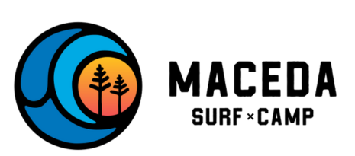
- HOME

- CONCEPT

- ACCOMODATION

- Morocco Trip

- ACTIVITIES

- JOURNAL

- FAQ

- BOOK NOW
LAST CHANCE FOR Moroccan Trip
Experience the magic of Morocco, Maceda style
Exotic new destination. Same feel-good Maceda vibes. Fly south to surf, taste and explore Morocco on a once-in-a-lifetime trip where everything is taken care of.

Surf
Experience the thrill of surfing Morocco – ride the waves at a secret spot untouched by mass tourism, where the laid-back atmosphere makes every session unforgettable.

Explore
Wander through vibrant souks, explore Essaouira’s coastal streets, hike ancient landscapes, And uncover hidden oases in the valley.

Relax
Stay in a quiet fishing village, perfect for relaxation and connecting with Morocco’s serene coastal charm.

Experience
Immerse yourself in Moroccan culture and learn more about Africa’s most visited country.
Only 6 spots available – book now!
Ready to fly south for the winter? Join the Maceda family in Morocco
Tuesday, January 13, 2025 – Tuesday– January 20, 2026

After thousands of guests, countless Plums & Rhum nights and too many epic surf sessions to remember, we’re taking Maceda on the road.
Loïc, Rachel and our team leaders Niki and Miou-Miou the cat will meet you in Morocco for a week-long adventure. We’ll experience this vibrant country the way it’s meant to be experienced – by immersing ourselves in the many unique, surprising and fascinating aspects of Moroccan culture.
Did we mention there will be amazing waves, too? Our charming accommodation is situated in a fisherman’s village, between Essaouira and Imsouane. But surfing is just one part of the adventure.
We have so many cool things planned, and our dream is to bring everything you love about Maceda – the friendly vibes, warm atmosphere and fun times – to this stunning African country.
If you dream of visiting Morocco, crave the warm sun in winter or simply want to tick another world-class surf destination off the list, this is your chance.
What's Included?

7 days in a charming Moroccan bed and breakfast

Surf guiding with Loic

Surf Morocco’s beginner-friendly and uncrowded waves.

Explore Essaouira Medina

Hike in our secret Valley and cool off with a swim.

Get lost amongst the real marocan souk

Surf lessons with Loïc

Visit a local farm and an Argan Cooperative

Discover the traditional hammam

Surfboards, wetsuits, wax etc. provided by us

3 meals per day included in the price

Surf safari
Total price for 7 days €670 in Early Bird
BOOK NOW
Testimonials

Loïc + Rachel
“Both Rachel and myself (and Niki) are bringing those down-to-earth, fun and welcoming Maceda vibes to Morocco! We’ll meet you there in the van and show you around the country where we actually met. It’s a special place for us, and we can’t wait to share it with you. Ready to see the real Morocco?”

Caelum Davies
“Before going I saw so many reviews saying they didn’t want the holiday to end, and that’s exactly the same for me. This was an amazing week with the best chill vibes.”

Martin Schä
“I had an absolutely fantastic time! The atmosphere there is so welcoming, making you feel like part of a big, happy family.”

WD D
“What a lovely atmosphere you have there! I really enjoyed my stay at your camp. It was a home away from home.”

Kat B
“Very happy with my entire stay and was so sad to leave! Miss you all!”

Mary Loo
“Loic is a really kind guy who teaches you both theory and practice and explains everything in a very good way. Very good for beginners, because he starts slowly to give you a feeling for the ocean/waves before you get on the surfboard, which makes you feel very comfortable!”
Ready to fly south for the winter? Join the Maceda family in Morocco
Here’s a sneak-peek of what the week will look like…
Day 1.
K
Saturday
Traditional Moroccan dinner and check-in.
Day 2.
K
Sunday
Surf Lesson, Grill fish on the beach and exploration of our village.
Day 3.
K
Monday
Fisherman walk and Sunset surf.
Day 4.
K
Tuesday
Essaouira’s medina Excursion, Visit of the Argan Cooperative and Experience the traditional hammam
Day 5.
K
Wednesday
Surf Safari and Yoga Sunset
Day 6.
K
Thursday
Souk, Visit of Imsouane and surf in a secret beach.
Day 7.
K
Friday
Hike ancient landscapes, uncover hidden oases in the valley and visit of a local farm with our marocan friend Hassan.
Day 8.
K
Saturday
Final breakfast


Anushka Mahesh
“One of the best weeks of my life! Super friendly hosts that made sure everyone felt at home and included”

Sarah Zschörner
“I had an amazing time. The whole place is magical, the atmosphere is welcoming and the staff really works well together.”

Olga Sizykh
“The people, the instructors, the tasty breakfast, the vibe, all of it is fantastic and you should book a stay.”

Susana Caldeira
“I had such a good time! It was the holiday I needed. Met so many light-hearted people.
Really enjoyed the surf lessons and yoga.”

Sabrina Reale
“Loic, Kate and Rachel made my stay super enjoyable. They and the volunteers managed to make the best out of my holidays.”

Stefan Cekic
“One of the most wholesome experiences I’ve had at any hostel. Feels like home, hosts are warm and welcoming.”

Bonny Allen
“The team have created an environment that attracts good vibes, allowing you to recharge your internal batteries and feel part of the Maceda Surf family.”
Spaces are filling up fast – book now!
Frequently Asked Questions
Q. How many days is the trip?
The trip runs from Saturday to Saturday, so 7 full days.
Q. What do I need to bring?
Passport, clothing, travel essentials, towel and any necessary medication are all must-haves for your trip. Additionally, we recommend bringing a camera or phone to capture the beautiful sights and memories from your adventure. Don’t forget to pack comfortable shoes for walking and exploring!
Q. What airport will I fly into?
Essaouira Airport is the closest airport to our destination. Second one being Agadir. Essaouira, Agadir and Marrakech transfers available from €30 to €100
Q. How do I get to the accommodation?
Contact us and we’ll help you plan your arrival with ease.
Q. Does Morocco get cold in winter?
Yes, in the evenings. The average daytime temperatures in Morocco during December/January is 20-25°C, with average nighttime temperatures around 10-13°C.
Q. Do I need to be an experienced surfer?
Hell nawh! Naturally, it helps to be comfortable in the water and have some basic swimming skills, but our expert instructors will provide all the necessary gear, training and guidance for beginners.
Q. Do I need to bring my own surfboard?
Nope, we have everything you need including wetsuits, surfboards and other surf equipment.
Q. Will I need my own money?
Transport, experiences, food and accommodation are included in the price, but we suggest bringing some spending money too. The local currency is the Dirham.
Q. Do I need travel insurance?
Yes, we always recommend getting travel insurance to avoid any unexpected issues, however, it’s not mandatory.
Q. What clothing should I bring?
While Morocco in December/January is warmer than Europe, you should pack a light jacket or sweater for cooler evenings. Loose-fitting, breathable clothing is ideal for sunny days. Make sure you bring swimwear and towels as well.
Q. Can we drink the tap water?
Yes, in our village the water from the tap is drinkable.
Save your spot now!
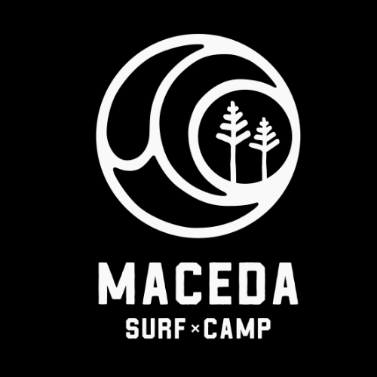
HOME
CONCEPT
accomodation
ACTIVITIES
JOURNAL
FAQ
TERMS & CONDITIONS

Rua Da Charneca 647
3885 – 722
Maceda.
◊
macedasurfcamp@gmail.com

+351 968 359 530

@macedasurfcamp
Copyright 2024 © MaCEDA SURF CAMP
Website by Digital Rogues

